**Baa, Baa, Black Sheep**

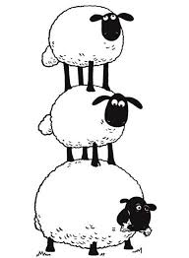

Baa baa black sheep, have you any wool?

Yes sir, yes sir, three bags full!

One for the master,

one for the dame,

And one for the little boy who lives down the lane.

Thank you said the master,

Thank you said the dame

And thank you said the little boy who lived down the lane.